Compréhension de l’écrit| Covid 19 BBC News

Covid: Europe sees record virus case rise
Published 29th December 2021
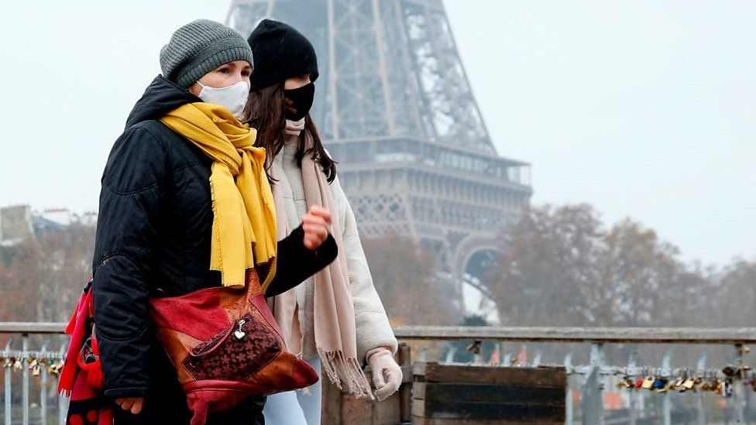
France has reported Europe's highest ever number of new daily Covid cases as countries across the continent struggle to contain the Omicron variant.
But France, with its 179,807 cases on Tuesday, was not alone in breaking records, as Italy, Greece, Portugal and England all reported record highs too. The figures could be due in part to reporting delays over Christmas.
Image source, Getty Images
Countries had been reporting rises running up the festive period, driven by the more contagious Omicron variant.
Studies suggest it is milder than Delta, with a 30% to 70% lower chance of infected people ending up in hospital. However, the World Health Organization (WHO) has warned that a surge in cases across Europe will push health systems towards the brink of collapse.
According to the WHO's weekly Covid update published on Tuesday, the number of new Covid infections grew by 57% in Europe in the week before 26 December, and by 30% in the Americas region.

Record daily rises in Europe
On Monday, French health minister Olivier Véran warned "everything suggests" France could see as many as 250,000 cases a day by the start of January, while the French Hospital Federation has said that the "most difficult weeks are yet to come".
France's Prime Minister Jean Castex announced new restrictions earlier this week including at least three days a week mandatory working from home for those who can from early January. The country's booster rollout has also ramped up, with more than 23 million having received a booster to date.
Elsewhere in Europe:
(…)
However, while a number of cities - including Paris, London and Berlin - have cancelled official New Year's celebrations, some governments have been less willing to bring in nationwide restrictions.
People in France and England have been asked to use their common sense, while the Spanish capital Madrid has said it will go ahead with its celebrations with a cap on the number of attendees at Puerta del Sol square.
Italy, meanwhile, has banned outdoor events and closed nightclubs but there are no restrictions on private gatherings.
https://www.bbc.com/news/world-europe-59810713

